Usage Patterns of Messaging Apps:WhatsApp vs. Telegram vs. Instagram

Hansika Geetesh Gond
[SYBScIT]
B.Sc. (Information Technology)
2025-2026

Under the Guidance of
Ms. Ansari Nusrat
Asst. Professor,
Department of Information Technology


Mansi Bharat Gada Degree College of Commerce,
Anjurphata, Bhiwandi.
Academic Year: 2025-2026



Oswal Shikshan & Rahat Sangh Sanchalit
MANSI BHARAT GADA DEGREE
COLLEGE OFCOMMERCE
(Affiliated to University of Mumbai)
(NAAC Accredited ‘B’ Grade& ISO 9001:2015 certified)

CERTIFICATE

I hereby certify that Ms. Hansika Geetesh Gond, Student of Mansi Bharat Gada Degree College of Commerce, with Roll Number:,12 has successfully completed a project titled “Usage Patterns of Messaging Apps:WhatsApp vs. Telegram vs. Instagram” in the subject of Field Project of SYBScIT Semester III, under the specialization of Information Technology, for the academic year 2025-2026.
To the best of my knowledge, the work submitted by the student is original, and the information included in the project is accurate and authentic.

Internal Guide Head of the Department Principal

DECLARATION

I, Ms. Hansika Geetesh Gond Student of Mansi Bharat Gada Degree College of Commerce studying in SYBScIT (Semester-III) with Roll Number:12, hereby declare that I have completed the field project titled “Usage Patterns of Messaging Apps:WhatsApp vs. Telegram vs. Instagram” during the academic year 2025-2026.
I confirm that this project report is my own work. The information and data in this report are correct and have been collected and studied using primary sources as part of this project.
I have given proper credit to all sources used in this report by listing them in the Appendix, as per the given format.

Signature of the Student
Ms.Hansika Geetesh Gond

ACKNOWLEDGEMENT

I would like to express my heartfelt gratitude to everyone who supported and guided me in completing this project successfully.
First and foremost, I sincerely thank our Principal, Mr. Mitesh Gosrani of Mansi Bharat Gada Degree College of Commerce, for providing me with the opportunity and resources to carry out this project.
I extend my deep gratitude to our Head of Department, Ms. Ansari Parveen from Information Technology for her constant encouragement and valuable guidance throughout the academic year.
I am especially thankful to my Internal Guide, Ms. Ansari Nusrat, Asst. Professor, Department of Information Technology, for her continuous support, helpful suggestions, and encouragement at every stage of this project.
I also express my special thanks to my parents and family members for their love, motivation, and constant support, which helped me stay focused on my work.
My sincere thanks to my classmates and friends for their cooperation throughout this project journey.
Lastly, I would like to thank all the individuals and organizations who shared their time and valuable information, through which the data for this project was collected. Without their help, this project would not have been possible.

ABSTRACT

Messaging applications have become central to modern communication, offering fast, reliable, and convenient ways to stay connected. Among these, WhatsApp, Telegram, and Instagram are widely used due to their unique features and growing popularity. This project examines the usage patterns of these three apps, focusing on user preferences, frequency of use, and the purposes for which they are adopted.
A mixed-method approach was used, combining surveys for quantitative data and interviews for qualitative insights. Google Forms and Excel helped in collecting and analyzing responses from students and young professionals, who represent a major segment of active users.
The study found that WhatsApp is the most preferred platform for everyday communication, valued for its simplicity, accessibility, and universal reach. Telegram is chosen for its privacy, large group features, and secure channels, making it suitable for community-based interactions. Instagram, while primarily a social networking app, is also used for messaging, especially by younger users who prefer combining chat with multimedia and entertainment.
The analysis shows that factors such as privacy, ease of use, multimedia features, and social interaction strongly influence app selection. While all three apps overlap in function, each serves a distinct role: WhatsApp for personal and academic conversations, Telegram for secure and large-scale engagement, and Instagram for social and creative communication.
The project concludes with recommendations for developers to strengthen security and usability, and for educators and businesses to use these platforms effectively. The findings contribute to understanding how messaging apps shape digital interaction and highlight the evolving trends in communication technology.

TABLE OF CONTENTS

Sr.No | Particulars | Page.No
1. | Abstract | 5
2. | Table of Contents | 6
3. | List of Figures | 7
4. | Chapter 1:Introduction | 8
5. | Chapter 2:Literature Review | 9
6. | Chapter 3:Methodology | 10
7. | Chapter4:Field work Description,Observation and Analysis | 15
8. | Chapter 5:Conclusion and Recommendations | 17
9. | References | 18
10. | Appendices | 19

LIST OF FIGURES
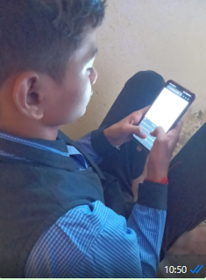
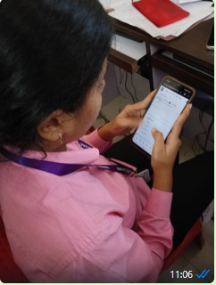

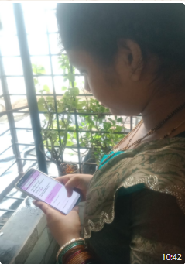
Sharing the knowledge
Filling the Form

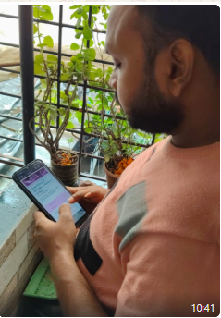
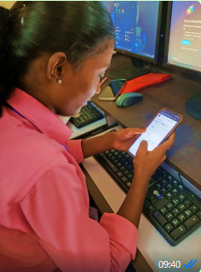

Official form being filled out

Form filling in progress
Collecting information
CHAPTER 1:Introduction

In the modern digital world, messaging applications have become an essential part of daily communication. They allow people to stay connected, share information, and interact instantly. Among the most popular platforms, WhatsApp, Telegram, and Instagram are widely used by students, professionals, and the general public. Each app has its own unique features: WhatsApp is known for its simplicity and wide adoption, Telegram is valued for its privacy and large group features, and Instagram combines social networking with messaging, which is especially popular among younger users. With the growth of smartphones and internet access, these apps have changed the way people communicate and build social connections.The problem, however, is that while people often use multiple apps at the same time, the reasons for preferring one platform over another are not clearly understood. Most research studies focus on individual apps but do not compare them in detail, creating a gap in understanding the factors that influence user choices.The objective of this study is to analyze the usage patterns of WhatsApp, Telegram, and Instagram, to identify what influences user preferences, and to compare their features and purposes. The scope of this study is limited to students and young professionals, who represent the most active group of users. Data has been collected through surveys and interviews, focusing only on these three platforms.This study is significant as it helps in understanding the changing communication trends of today’s generation. The results can help app developers improve features, educators adopt better tools for learning, and businesses design effective communication strategies. Overall, this research provides useful insights into how messaging apps shape social interaction and digital communication in everyday life.

CHAPTER 2:LITERATURE REVIEW

Since 2021
A security analysis comparison between Signal, WhatsApp and Telegram
CE Bogos, R Mocanu, E Simion - Cryptology ePrint Archive, 2023 - eprint.iacr.org

Since 2024
On the Efficacy of Instant Messaging Apps
SNFSM Khomsah, K Ariffin - … Journal for the Social Sciences (e …, 2024 - gadingssuitm.com

Since 2025
An Interactive Comparison of WhatsApp, Telegram, and Google Classroom: Usability and User Experience Insights
R Alsanossi, M Mohammed - AlQalam Journal of Medical and …, 2025 - journal.utripoli.edu.ly

By Relevance:
[HTML] Inscreva-se em nossa newsletter: Busca< span class=" sans"> Identifying existing research on Emoji or Emoticons usage in HealthCare:</span> A scoping …
TFR Lucene, AL do Nascimento, LP de Oliveira - revista.internetlab.org.br

Review Articles:
[PDF] A Systematic Review of The Relationship Between Social Participation and Psychological Factors in Social Media among Youth
R Changning, AH Ahmad Ghazali… - International Journal of …, 2023 - kwpublications.com

CHAPTER3:METHODOLOGY
3.1 Research Method:
This study used a Mixed Method approach, combining structured surveys for quantitative data with open-ended responses for qualitative insights. Quota sampling ensured representation across age, occupation, and platform usage experience to better understand user behavior, preferences, and content consumption patterns across WhatsApp, Telegram, and Instagram messaging functionalities.

3.2 Tools Used:
Questionnaire:
I created a structured questionnaire to collect information from users about their messaging app usage habits (frequency, duration, features used), platform preference, and security/privacy concerns related to WhatsApp, Telegram, and Instagram Direct Messages. It included both multiple-choice and open-ended questions for a mix of quantitative and qualitative data.

Interview:
I conducted brief interviews with selected participants to understand their personal experiences, reasons for platform loyalty/switching, and opinions related to the different features and communication styles associated with WhatsApp, Telegram, and Instagram messaging.

Software/Apps:
I used Google Forms to distribute the questionnaire and Microsoft Excel to organize responses, calculate percentages, and identify key trends and patterns in the data concerning messaging app usage.

3.3Sample Size:
The sample size for this study was 22 participants from diverse age groups, professions, and educational backgrounds. This variety helped capture a broader view of Usage Patterns of Messaging Apps:WhatsApp vs. Telegram vs. Instagram.

3.4Sampling Method (Non-Probability Sampling):
The four techniques—Convenience, Purposive, Quota, and Snowball Sampling—are all types of Non-Probability Sampling. These methods bypass random selection to quickly and affordably gather data from specific target groups, like users of WhatsApp, Telegram, and Instagram. They rely on convenient access and participant referrals (Snowball) while ensuring certain demographic targets are met (Quota). Because the sample isn't randomly selected, the findings provide rich insights but cannot be generalized statistically to the entire user population.

3.5Data Analysis:

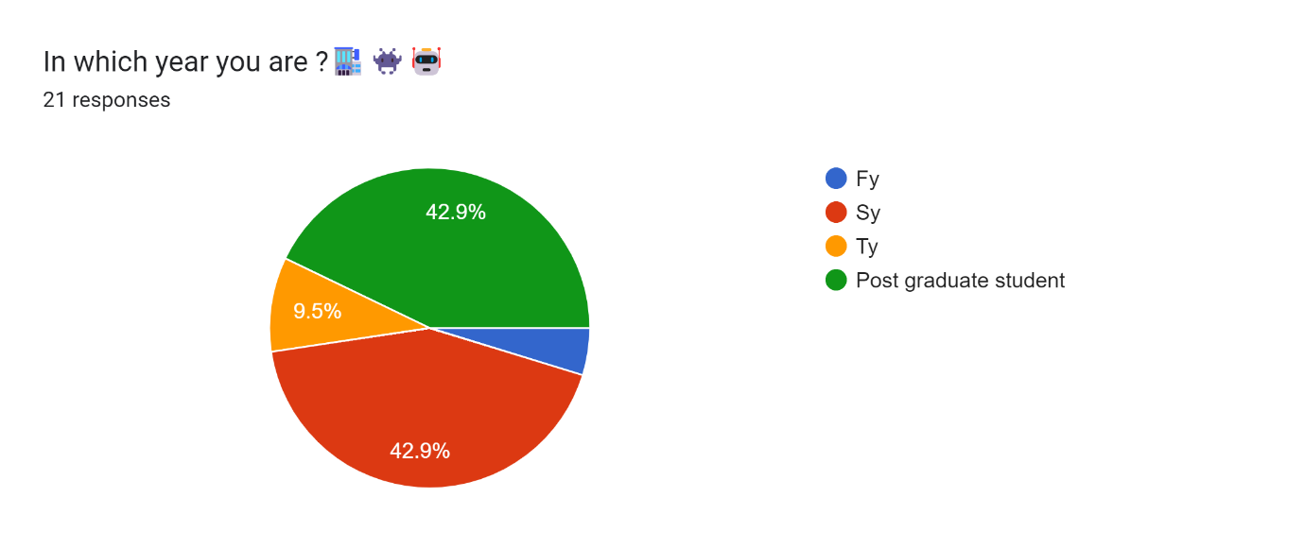

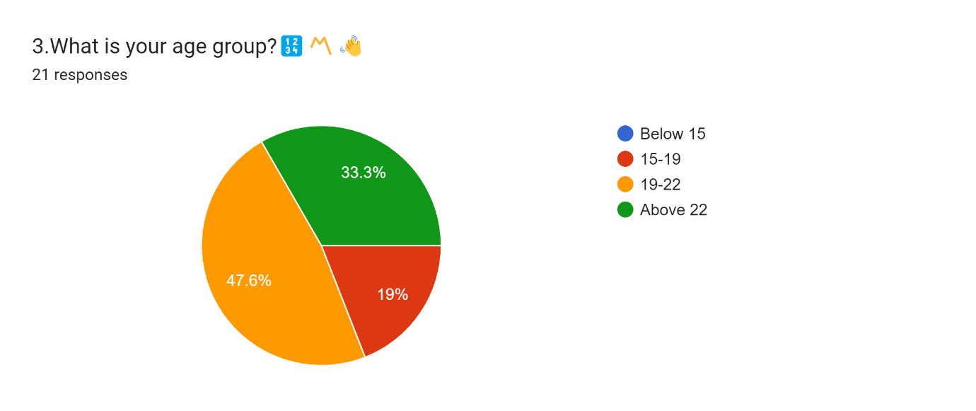

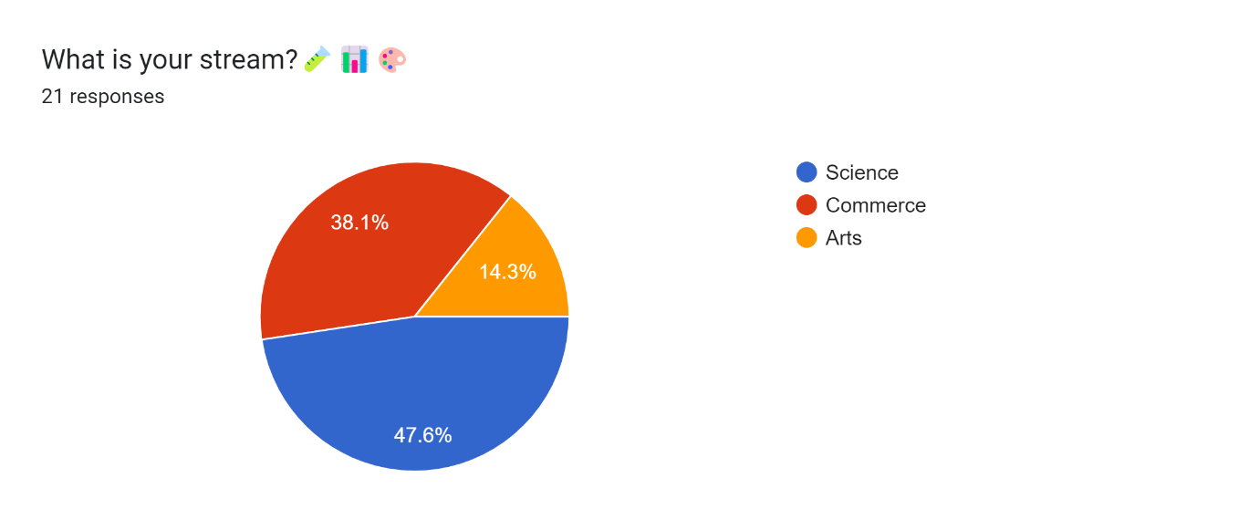

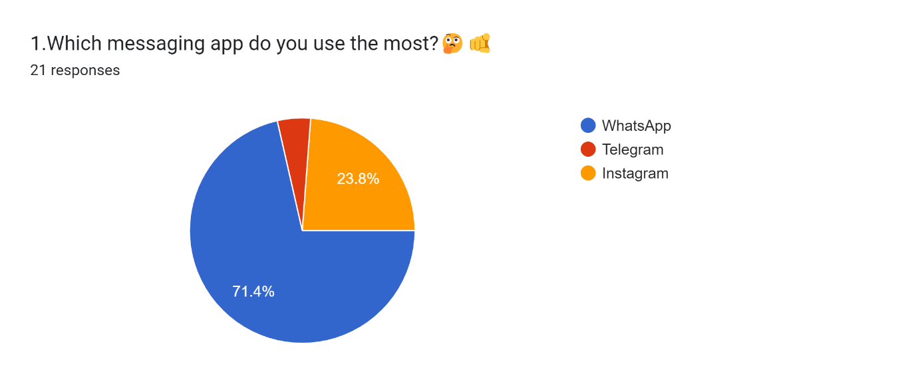

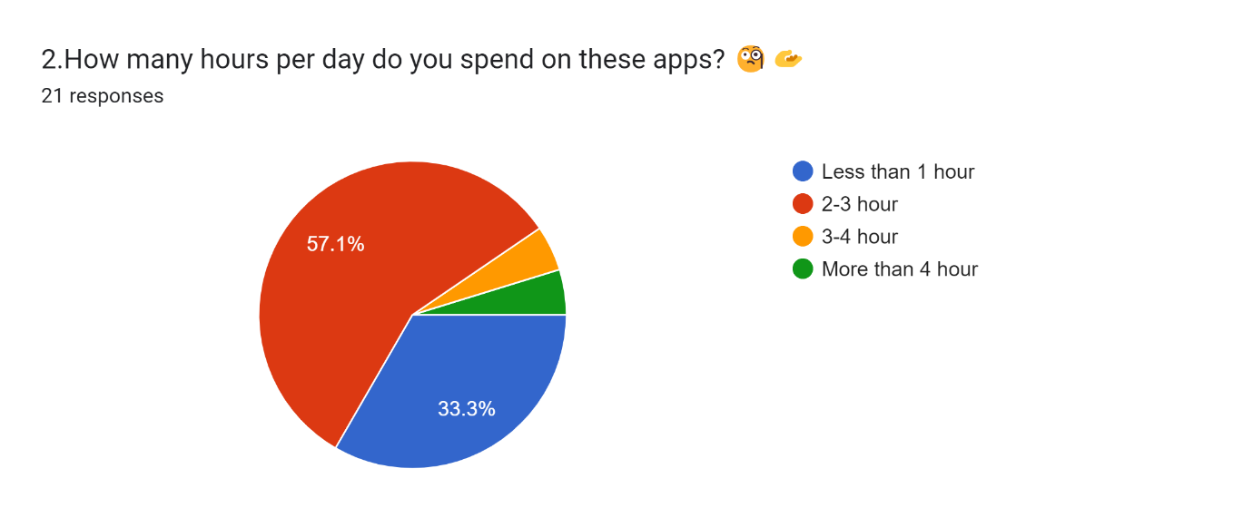

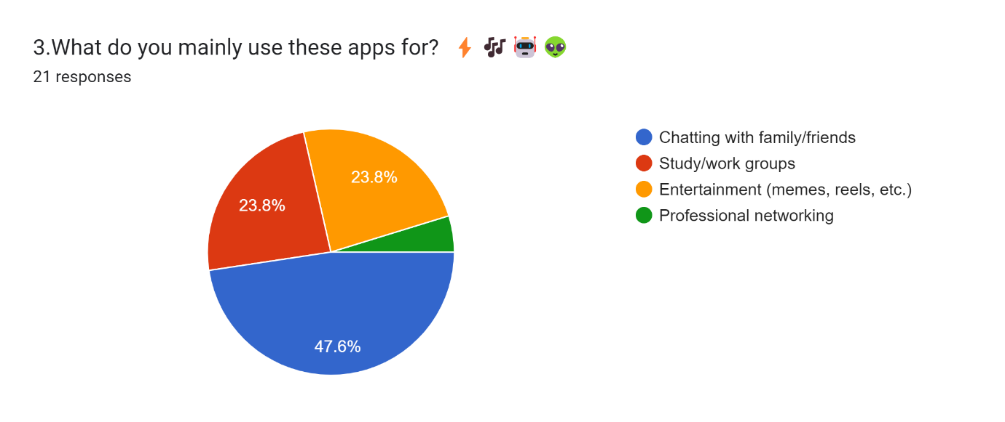

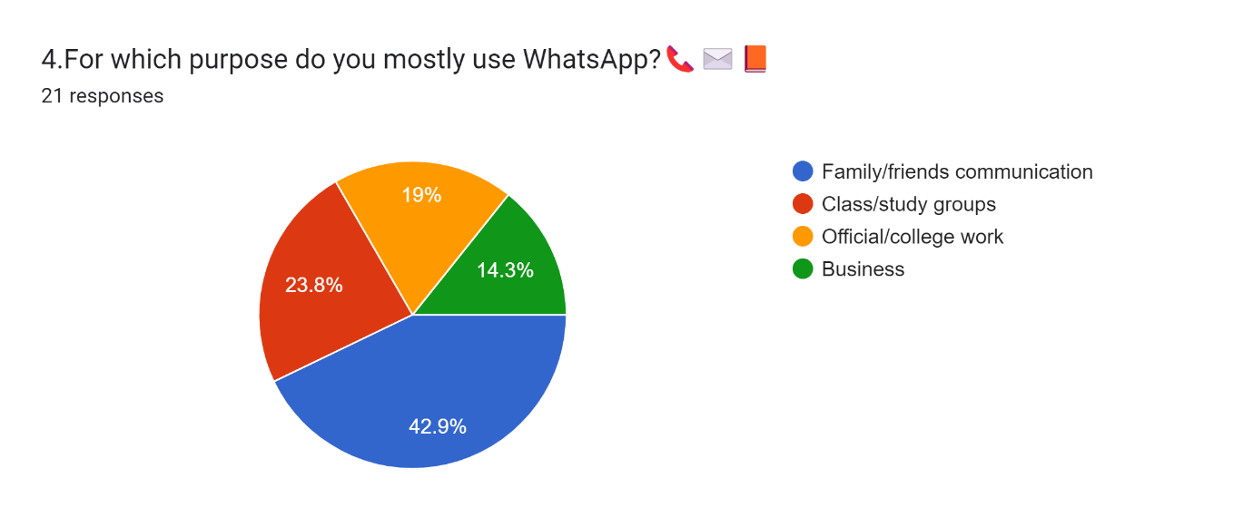
CHAPTER 4:

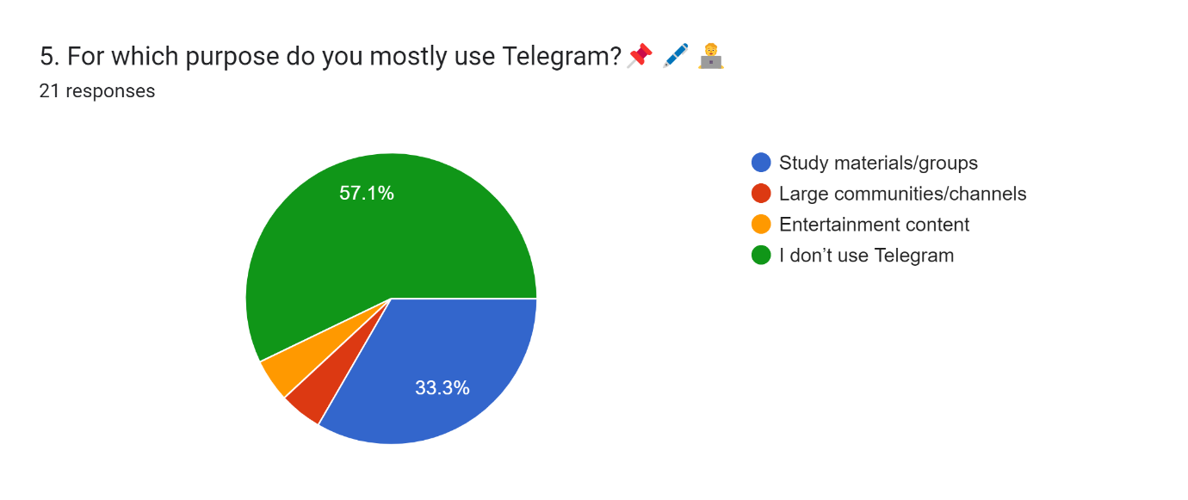

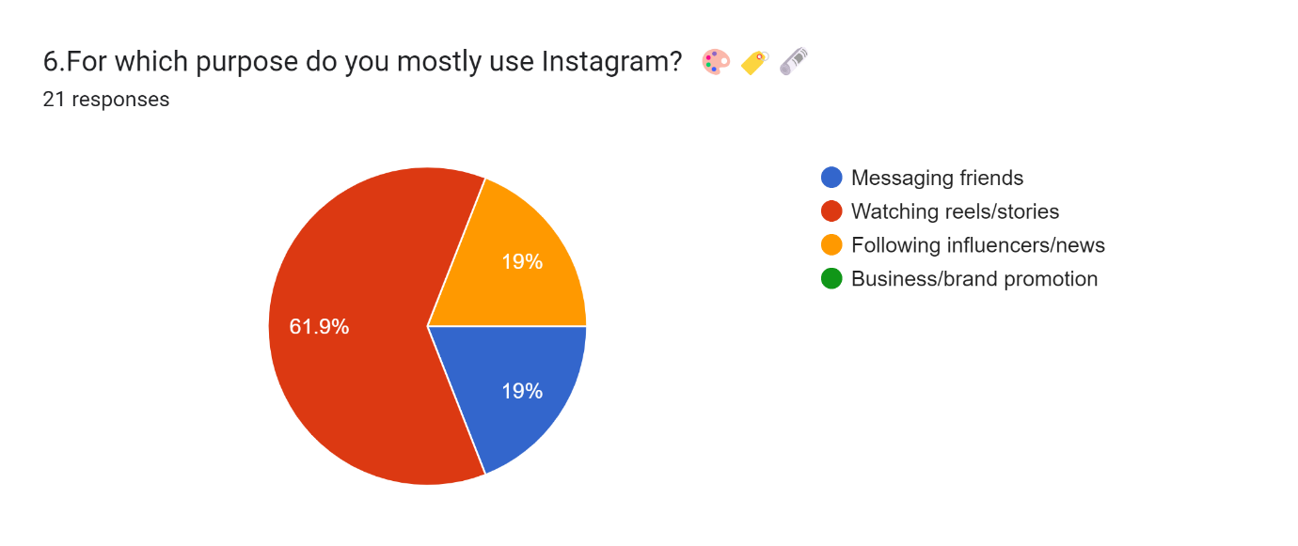

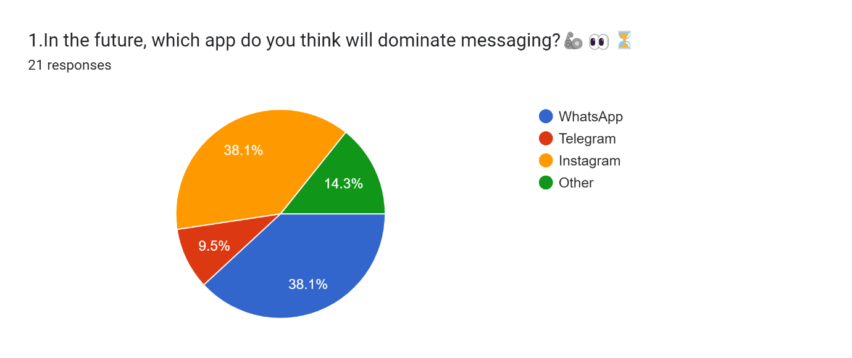

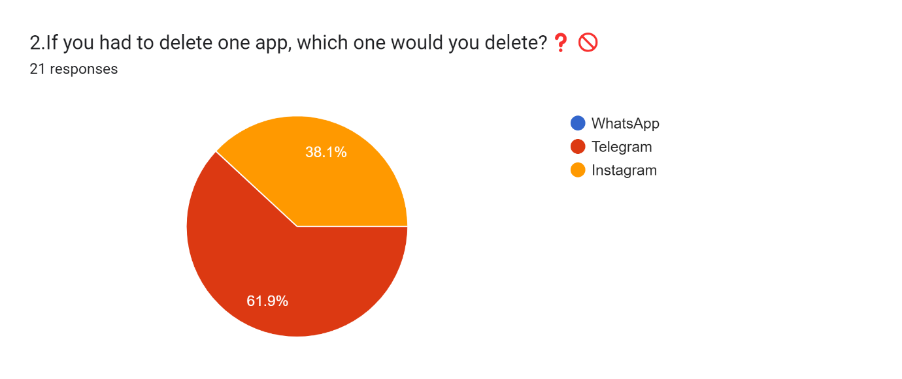

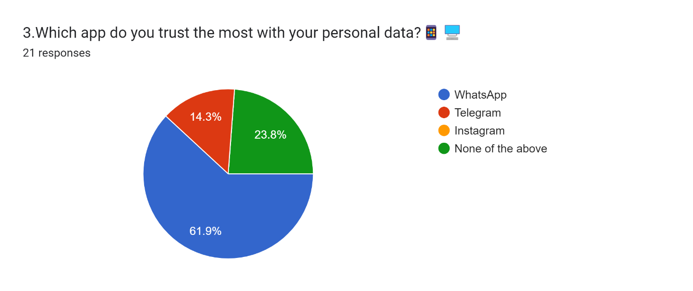

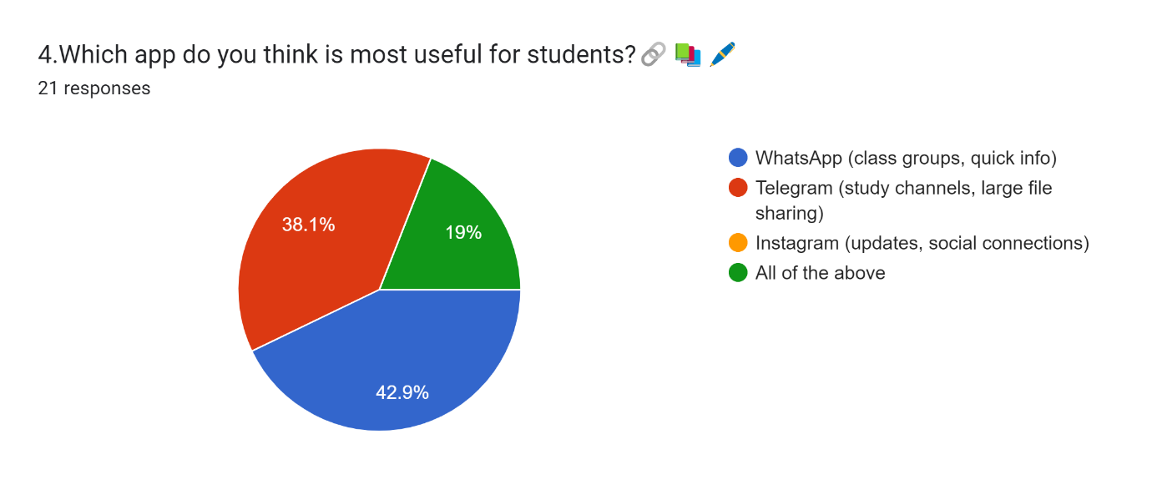

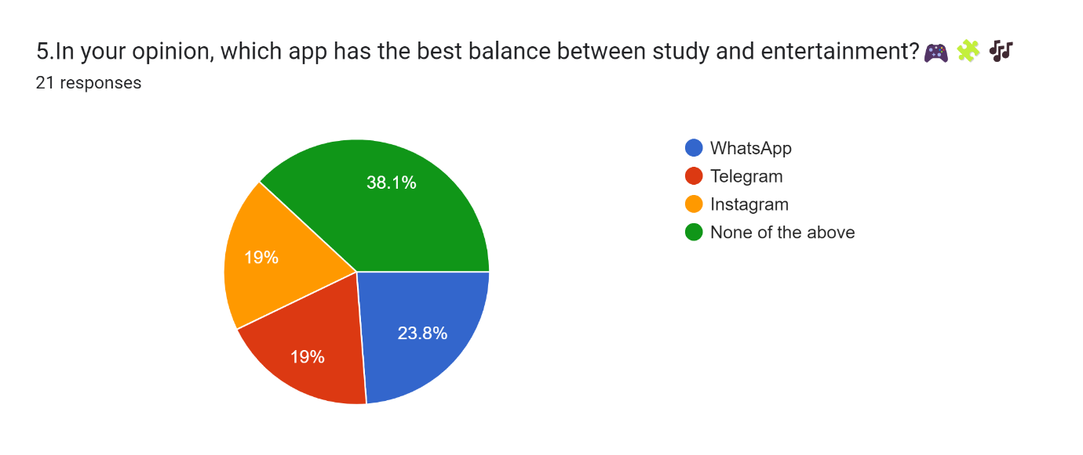

Chapter 4:Field Work Description,Observation and Analysis

4.1 Field Work Description:
When I went around observing, it felt like WhatsApp, Telegram, and Instagram were three friends with different moods. Students in the canteen couldn’t stop buzzing on WhatsApp, using it for groups, notes, and quick gossip. A quieter bunch preferred Telegram, sharing files, links, and enjoying the privacy it gave. Meanwhile, teenagers in the park were all about Instagram DMs, reacting to stories and reels while chatting in a fun, visual way. It was clear that people use WhatsApp for daily needs, Telegram for selective sharing, and Instagram for trendy, stylish conversations.
4.2 Observations:
From my observations, WhatsApp stands out as the most widely used app for everyday communication, especially among students and families, since it is simple, quick, and reliable for class groups, updates, and casual chatting. On the other hand, Instagram and Telegram serve more specific purposes—Instagram is mostly used by the younger crowd for fun and social bonding through reels, stories, and DMs, while Telegram is preferred by people who value privacy, large file sharing, and niche discussion groups. Together, these patterns show that while WhatsApp is a daily necessity, Instagram and Telegram are more about lifestyle choices and selective use.
4.3 Analysis:
The survey on messaging app usage, primarily among SY students aged 19–22, revealed WhatsApp is the clear leader for daily communication (2–4 hours daily usage) and is essential for both personal (family/friends) and academic (study groups) needs. Instagram followed as the second choice, used mainly for entertainment, reels, and social updates. Telegram was a distant third, valued selectively for study materials, large file sharing, and communities, with many students not using it. Participants overwhelmingly predicted WhatsApp would maintain its dominance, viewing it as the most trusted platform, and would delete Telegram if forced, confirming its least essential role.

Chapter 5: Conclusion and Recommendations
5.1Conclusion:
The study concludes that messaging apps are vital to students' routines, but each serves a distinct purpose. WhatsApp is the dominant platform due to its simplicity and universal acceptance, making it the essential tool for personal and academic groups. Instagram is favored by youth for entertainment, reels, and social media content. Telegram occupies a niche role, valued for privacy, large communities, and file sharing. Essentially, the apps are complementary, with users strategically choosing the best platform for a specific context—daily necessities (WhatsApp), secure sharing (Telegram), or lifestyle and fun (Instagram).
5 5.2 Recommendations :
- For App Developers: Prioritize enhancing security, privacy, and overall ease of use to strengthen user trust.
- For Educational Institutions: Actively leverage WhatsApp and Telegram for official class communication, academic updates, and sharing study materials.
- For Students: Implement time management strategies to balance entertainment (Instagram) with essential academic use (WhatsApp/Telegram).
- For Businesses/Professionals:
  - Use Telegram channels and WhatsApp groups for focused, professional communications.
  - Target younger audiences and promotion via Instagram's visual and social features.
- For Future Research: Expand the study's scope to include working professionals and a broader range of age groups to capture a complete picture of general messaging app usage.
REFERENCES
References from Our Conversations
Primary Source
➢ Google Form Survey. (2025). Survey on Online Payment Awareness
Empowering Every User Google Form link:
https://docs.google.com/forms/d/e/1FAIpQLSd9gNuZ-yUcj6JPtiQqaKIKY5-NZ2TGE3ana2yGb52PUmVXrQ/viewform?usp=dialog
- Google Form Survey. (2025). Survey on the Usage Patterns of Messaging Apps: WhatsApp, Telegram, and Instagram
[Unpublished raw data]. Google Form link:
ResearchGate

Government & International Reports
- Pew Research Center. (2024). Teens, Social Media and Technology 2024.
https://www.pewresearch.org/internet/2024/12/12/teens-social-media-and-technology-2024/
- World Health Organization. (2023). Gaming disorder: Public health perspectives.
https://www.who.int

Journal Articles & Research Papers
- Paoletti, G., Almeida, J. M., Vassio, L., Gonçalves, M. A., & Mellia, M. (2025). Join the Chat: How Curiosity Sparks Participation in Telegram Groups.
arXiv. https://arxiv.org/abs/2503.13635
- Yoon, S., Wee, S., Lee, V. S. Y., Lin, J., & Thumboo, J. (2021). Patterns of use and perceived value of social media for population health among population health stakeholders: a cross-sectional web-based survey.
BMC Public Health, 21, 1312. https://doi.org/10.1186/s12889-021-11370-y
- Khan, N. A. (2022). Scale development and validation for usage of social networking sites.
https://pmc.ncbi.nlm.nih.gov/articles/PMC9212287/

News Articles
- Business Insider. (2025). Telegram hits 1 billion active users as CEO Pavel Durov takes swipe at Meta-owned rival WhatsApp.
https://www.businessinsider.com/telegram-celebrates-1-billion-active-users-pavel-durov-swipe-whatsapp-2025-3
- AP News. (2025). Instagram's 'deliberate design choices' make it unsafe for teens despite Meta promises, report says.
https://apnews.com/article/13276348cde2dcc1ee94c66227ea25dc

APPENDICES
Appendix A
GUIDE INTERACTION DIARY FORM

I,the undersigned Ms.Hansika Geetesh Gond, Roll No. 12 studying in the 2025-26 Year of SYBscIT Fulltime Course is doing my project work under the guidance of Ms. Ansari Nusrat, wish to state that I have met my Internal guide on the following dates mentioned below for Project Guidance:-

Sr.No. | Date | Signature of the Internal Guide
1 | 4th September 2025
2 | 12th September 2025
3 | 17th September 2025
4 | 19th September 2025
5 | 20th September 2025
6 | 24th September 2025

________________________ ______________________
Signature of the Candidate Signature of Internal Guide
Appendix B-Google Form Questions

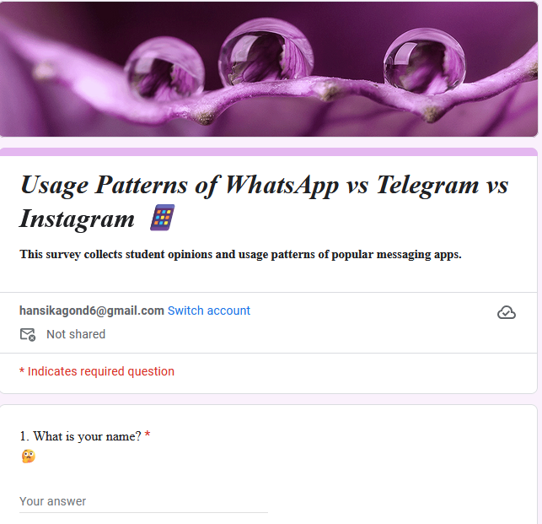

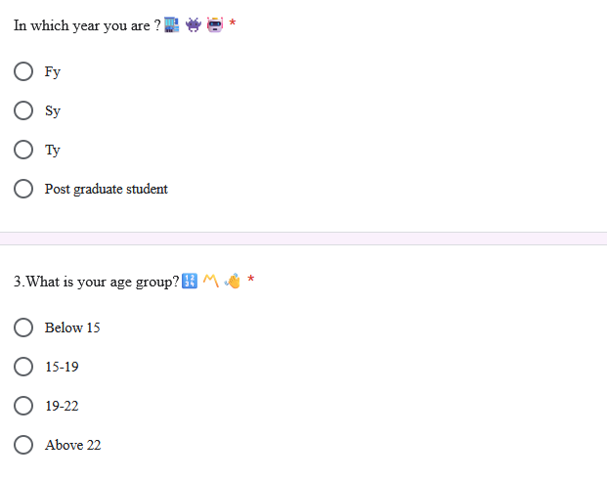
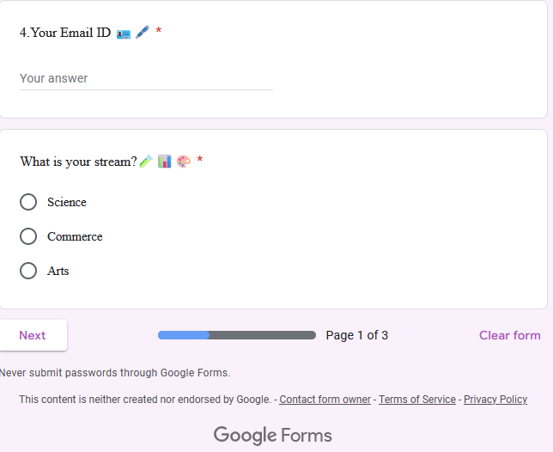
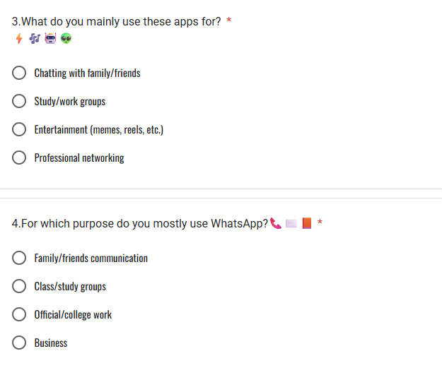
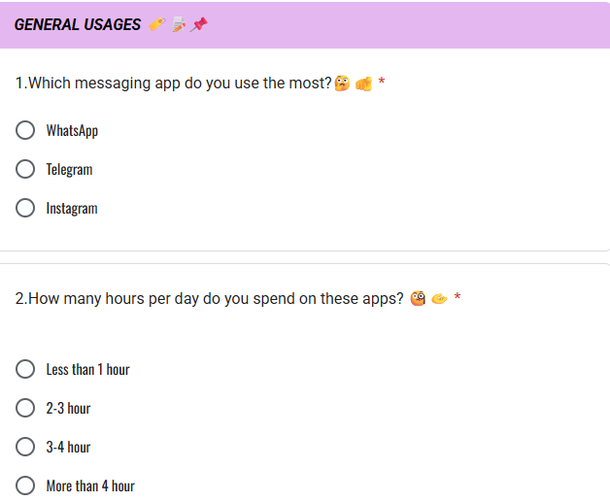
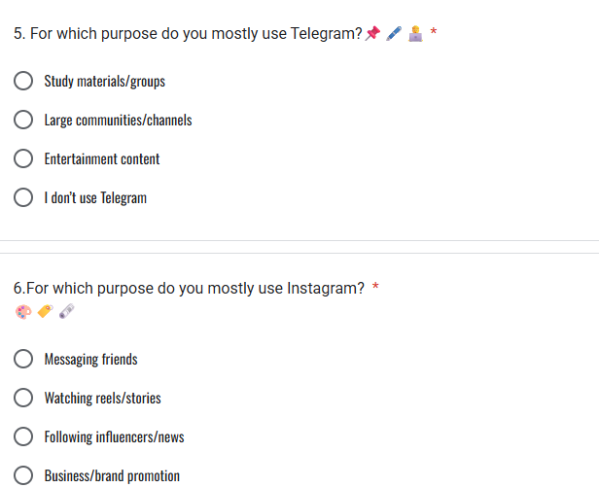
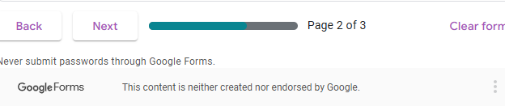
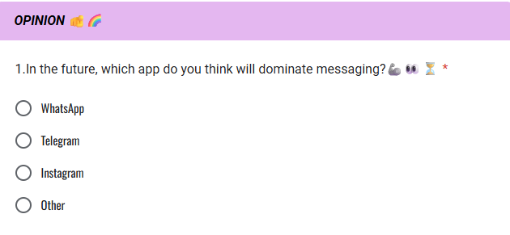

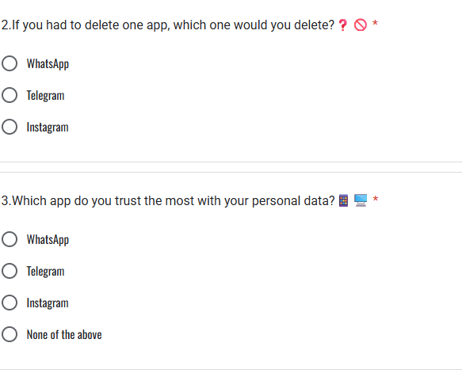

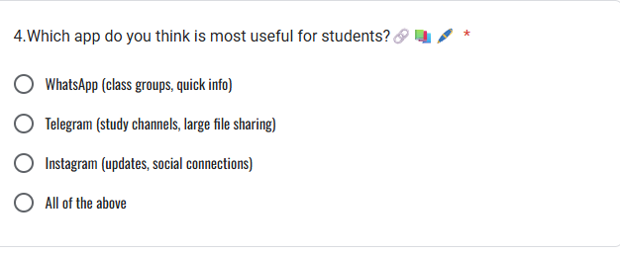
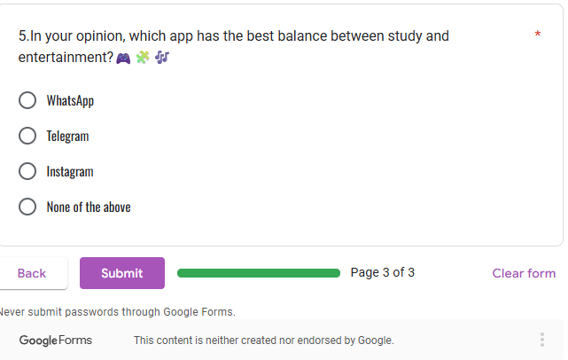
APPENDIX C:Sample Data(Excel Table)

 | Timestamp | 1. What is your name?  🤔 | 4.Your Email ID 🪪🖋️
 | 9-16-2025 23:29:36 | Achal yadav | achalyadav205@gmail.com
 | 9-16-2025 23:32:46 | Gupta Aradhya ganesh | aradhyagupta860@gmail.com
 | 9-16-2025 23:48:25 | Goli sneha Naresh | snehagoli42@gmail.com
 | 9-16-2025 23:50:46 | Jha mohit murari | mohitjha648@gmail.com
 | 9-16-2025 23:55:06 | Riddhi Patil | patilriddhi345@gmail.com
 | 9-17-2025 0:00:45 | Shalini Thakur | shalinithakur7841@gmail.com
 | 9-17-2025 0:12:40 | Sakshi | gaursakshi7869@gmail.com
 | 9-17-2025 9:29:41 | vaishnavi goud | vaishgoud123@gmail.com
 | 9-17-2025 12:20:31 | Aishwarya | aishwaryakharat2903@gmail.com
 | 9-17-2025 15:28:15 | Mahek | maheksingh647@gmail.com
 | 9-17-2025 16:38:20 | Jignesh | jigneshforall@gmail.com
 | 9-17-2025 21:50:25 | Ekta | pekta4387@gmail.com
 | 9-18-2025 0:06:03 | Sushmita | sushmitay215@gmail.com
 | 9-18-2025 12:41:22 | Harsh patel | Patelrutvik7029@gmail.com

STUDENT FEEDBACK ON FP
Student Name: Hansika Geetesh Gond
Seat No. /Roll No: 12
Email: hansikagond6@gmail.com
Department: Bachelor of science in information technology
Name of the Mentor: Ms.Ansari Nusrat
Title/Heading of Field Project: usage patterns of messaging apps (WhatsApp vs Telegram vs Instagram)
Brief description of FP carried out: My Field Project (FP) focused on studying the usage patterns of messaging apps—WhatsApp, Telegram, and Instagram. The project involved collecting data through surveys and interviews, analyzing user preferences, and comparing features of the three platforms. It highlighted how different factors such as privacy, ease of use, and social interaction influence user choices.
Dates of FP:
Was your internship experience related to your major area of study?
- Yes, to a slight degree

Indicate the degree to which you agree or disagree with the following statements.

This experience has: | Strongly  Agree | Agree | No opinion | Disagree | Strongly  Disagree
Given me the opportunity to explore a career field
Allowed me to apply classroom theory to practice |  |  | 
Helped me develop my decision-making and problem-solving skills | 
Expanded my knowledge about the work world before permanent employment | 
Helped me develop my written and oral communication skills
Provided a chance to use leadership skills (influence others, develop ideas with others, stimulate decision-making and action) |  |  | 
Expanded my sensitivity to the ethical implications of the work involved |  |  |  | 
Made it possible for me to be more confident in new situations |  |  | 
Given me a chance to improve my
interpersonal skills
Helped me learn to handle responsibility and use my time wisely |  |   
Helped me discover new aspects of myself that I didn’t know existed before |  |  | 
Helped me develop new interests and abilities |  | 
Helped me clarify my career goals |  |  |  |  | 
Allowed me to acquire information and/ or use equipment not available at my Institute |  |  | 
Allowed me to realize socio-economic issues in the society | 
*In the Institute FP program, faculty members are expected to be mentors for students. Do you feel that your faculty mentor served such a function? Why
Yes, my faculty mentor in the Institute FP program effectively served as a mentor. They provided personalized guidance, fostering both my academic and personal growth. Regular interactions ensured I received timely advice, helping me navigate challenges and make informed decisions.
*How well were you able to accomplish the initial goals, tasks and new skills that were set down in your learning contract? In what ways were you able to take a new direction or expand beyond your contract? Why were some goals not accomplished adequately?
I successfully achieved several goals outlined in my learning contract, particularly those related to enhancing specific skills and completing designated tasks. However, I expanded beyond the contract by exploring additional areas of interest and engaging in supplementary activities that enriched my learning experience
*In what areas did you most develop and improve?
During the Institute FP program, I notably enhanced my time management and communication skills. These improvements were achieved through structured planning and active participation in group discussions.
*What has been the most significant accomplishment or satisfying moment of your FP?
The most significant accomplishment of my Field Project (FP) was successfully completing the research objectives within the given timeframe. The most satisfying moment was receiving positive feedback and validation of my work from both peers and faculty.
*What did you dislike about the FP?
I disliked the time constraints and unexpected challenges during the FP, as they sometimes made it difficult to collect data and analyze it thoroughly. However, these challenges also taught me adaptability and problem-solving.
*Considering your overall experience, how would you rate this FP? (Circle one). –
Satisfactory/ Good/ Excellent
*Give suggestions as to how your FP experience could have been improved. (Could you have handled added responsibility? Would you have liked more discussions with your professor concerning your FP? Was closer supervision needed? Was more of an orientation required?)
My FP experience could have been improved with more regular discussions and guidance from my professor, which would have provided clearer direction.

Signature of Student
Name
Date:

